**Chapter 4**

**Results and Analysis**

In this chapter, we explain the results and analysis of our research project based on the experiments conducted on pure TiO₂ coatings. These coatings were prepared using the sol-gel method and applied on stainless steel surfaces.

The main objective of our study was to enhance the corrosion resistance, ensure biocompatibility, and maintain smooth surface properties of materials used in surgical tools and biomedical applications.

To study the properties and performance of the pure TiO₂ coatings, we used various characterization techniques, including:

* X-Ray Diffraction (XRD) – to examine the crystal structure
* Scanning Electron Microscopy (SEM) – to observe surface morphology and particle size
* UV-Visible Spectroscopy – to study light absorption behavior
* Salt Spray Test – to evaluate corrosion resistance
* Adhesion Test – to check how well the coating sticks to the surface

**4.1 Structural and Morphological Properties of Doped TiO₂**

In this section, we studied the structural and surface (morphological) characteristics of pure Titanium Dioxide (TiO₂) using X-ray Diffraction (XRD) and Scanning Electron Microscopy (SEM). These techniques helped us understand the internal atomic structure and surface quality of the material without any doping.

**Phase Identification**

The XRD pattern of pure TiO₂ shows sharp peaks that correspond mainly to the anatase phase, which is a common and stable crystalline form of TiO₂. No other peaks, such as rutile or brookite, were observed in our sample, indicating high phase purity. This confirms that the TiO₂ coating has a uniform and well-ordered crystal structure.

**Peak Position and Stability**

The peaks in the XRD graph appeared at their standard positions, matching with the JCPDS reference data for pure anatase TiO₂. There were no peak shifts, which means that the crystal structure remained stable and unchanged, and the sample does not contain any foreign atoms or defects.

**Crystallite Size Calculation**

Using Scherrer’s formula, the average crystallite size of pure TiO₂ was calculated from the most intense peak (usually the (101) plane). The result showed that the crystallite size lies in the nanometer range, which is ideal for various applications such as photocatalysis and coating performance. Small crystallites provide a large surface area, which improves material efficiency.

**Crystallinity**

The sharpness and high intensity of the XRD peaks indicate that the crystallinity of the sample is high. This means that the atoms in the TiO₂ coating are well-arranged, forming a solid and consistent structure. High crystallinity is beneficial for optical and mechanical performance in biomedical coatings

**4.1.2 Morphological Properties (SEM Analysis)**

Morphological properties relate to the shape, size, and surface texture of the material particles. These properties were examined using Scanning Electron Microscopy (SEM).

**Surface Appearance**

SEM images of the pure TiO₂ coatings showed a somewhat less uniform surface compared to doped samples. The surface appeared slightly loose and not as densely packed, which may offer less effective protection against corrosion.

**Particle Shape and Size**

The particles of pure TiO₂ appeared larger in size and more irregular in shape. This indicates that without doping, the dispersion of particles is not as controlled, and larger grains may form during synthesis.

**Effect on Surface Texture**

The surface of pure TiO₂ was relatively smoother and less compact than doped TiO₂. A smoother surface means reduced surface area, which may limit the photocatalytic activity and decrease corrosion resistance.

**Grain Boundaries and Porosity**

SEM images also revealed more noticeable pores and gaps in the pure TiO₂ coatings. High porosity can allow corrosive agents to penetrate easily, reducing the protective capability of the coating on surgical instruments.

The structural analysis (XRD) confirmed that the anatase phase of TiO₂ was clearly present in the pure sample, with sharp and intense peaks indicating good crystallinity. However, compared to doped samples, no shift in peak position or size reduction was observed, meaning no enhancement in structural properties occurred. Meanwhile, the morphological analysis (SEM) showed that pure TiO₂ had a less uniform surface with higher porosity, which are less desirable properties when aiming to improve corrosion resistance.

**4.2 Coating Surgical Instruments with Pure TiO₂ and Salt Spray Test Results**

In our research, we coated surgical instruments with titanium dioxide (TiO₂) to check how well it could protect against corrosion. We focused on the simple TiO₂ coating, without any doping elements like zinc or copper. To test the effectiveness, we used the Salt Spray Test, which simulates a harsh, salty environment to see how materials behave under corrosion stress.

**Why We Initially Chose TiO₂**

Titanium dioxide (TiO₂) is known for its good stability, photocatalytic properties, and biocompatibility, making it a potential coating material for medical tools. It also offers some level of corrosion protection by acting as a barrier between the metal surface and the environment.

**Results and Observations from Salt Spray Test**

**Pure TiO₂ Coated Instruments**

* When we applied only pure TiO₂ coating and conducted the salt spray test, corrosion spots appeared on the surface after some time.
* Small rust marks were visible.
* The coating seemed incomplete or not fully protective, especially in areas where the coating may have been thinner.
* This result showed that pure TiO₂, by itself, is not strong enough to resist corrosion in harsh environments like those encountered in clinical or surgical conditions.

**Conclusion on Pure TiO₂ Performance**

* While pure TiO₂ has some protective qualities, its performance in the salt spray test was not fully satisfactory. The coating:
* Was less dense and slightly porous, allowing saltwater to penetrate.
* Could not fully stop the corrosion process.
* Is not suitable alone for surgical tools that require long-term protection in demanding environments.

**4.3 Comparison Undoped and Doped TiO₂ Coating**

|  |  |  |
| --- | --- | --- |
| **Property** | **Undoped TiO₂ Coating** | **TiO₂ Doped with Cu and Zn** |
| Corrosion Resistance | Weak Corrosion appeared | No corrosion seen |
| Surface Protection | Less effective | Highly effective |
| Salt Spray Test Result | corrosion observed | No corrosion |
| Durability in Medical Conditions | Not reliable in long-term use | Reliable for long term use |
| Effectiveness | Basic protection | Advanced protection |

From our salt spray test results, we clearly found that coating surgical tools with pure TiO₂ does not provide complete protection from corrosion. Although TiO₂ forms a basic barrier layer on the surface, it was not strong enough to completely prevent rust in a moist and chemically active environment. This is an important finding, especially for medical tools that are reused and exposed to harsh sterilization conditions. The pure TiO₂ coating failed to fully protect the tools, which means there is a risk of corrosion developing over time. As a result, this can reduce the lifespan of the instruments and affect their hygiene, which is a serious concern in hospital settings.

**4.4 Adhesion and Uniformity of the Coating**

In medical applications, adhesion and uniformity play a major role in determining the performance, durability, and protection offered by surface coatings like TiO₂ on surgical instruments.

**Adhesion of Coating**

Adhesion refers to how strongly the coating sticks or bonds to the surface of the surgical instrument. If the coating does not adhere well, it can peel off or get damaged during cleaning, sterilization, or repeated use especially in hospitals where tools face harsh environments.

In our experiment, we observed that the pure TiO₂ coating showed weak adhesion. During the salt spray test, some parts of the coating became loose, and corrosion began to appear on the exposed metal. This indicates that pure TiO₂ may not form a very strong bond with the metal surface, leading to reduced protection and durability under real-world hospital conditions.

**Uniformity of Coating**

Uniformity means how evenly the coating covers the entire surface of the instrument. A uniform coating ensures equal protection across all areas, preventing rust or damage in exposed spots.

In the case of pure TiO₂ coating, SEM analysis showed a non-uniform surface. There were visible cracks, uneven thickness, and small gaps in some areas. These irregularities create weak spots, where corrosion can start or bacteria can accumulate. Such surface defects are not suitable for medical tools that require consistent and reliable protection.

**Adhesion and uniformity in Biomedical Coatings**

Good adhesion prevents the coating from coming off during cleaning, sterilization, or use. Excellent uniformity ensures full protection against corrosion, bacterial growth, and physical damage. Together, these two properties make the coating more reliable and effective for medical tools, which must remain safe, hygienic, and long-lasting.

**Microscopic Analysis (SEM)**

We used Scanning Electron Microscopy (SEM) to closely examine the surfaces coated with pure TiO₂. The SEM images of pure TiO₂ coating revealed a non-uniform surface, with visible pores, cracks, and uneven film thickness. These surface defects suggest that the pure TiO₂ coating may have weak spots, making it less effective in protecting against corrosion or microbial growth.

**Explanation Behind Weak Adhesion and Uniformity**

The poor performance in adhesion and uniformity of pure TiO₂ coating may be due to:

* Surface stress during deposition
* Cracks or defects in the film formation process
* Lack of bonding strength between the TiO₂ layer and the metal surface

These factors cause the coating to not spread evenly and reduce its ability to firmly stick to the substrate, especially when exposed to harsh environments.

**Implications for Biomedical Use**

Medical instruments used in hospitals must be:

* Corrosion-resistant
* Durable under repeated cleaning and sterilization
* Safe and effective for long term use

Our findings show that pure TiO₂ coating alone may not fully meet these critical standards. Its weak adhesion and poor uniformity reduce its ability to protect surgical tools or dental equipment over time. Therefore, for biomedical applications, further improvement in coating quality is necessary to ensure full protection and durability.

**4.5** **Characterization Techniques**

In our research project, different characterization techniques were used to study the structural, morphological, optical, and photoluminescence properties of pure TiO₂ (titanium dioxide) coatings applied to biomedical instruments. These methods helped us understand how the material behaves at both the micro and nano levels. By analyzing the results from each technique, we were able to confirm the quality, crystalline structure, surface features, and optical performance

**XRD Analysis Results**

In the X-ray Diffraction (XRD) analysis of the prepared pure TiO₂ thin film samples, the technique was used to examine the crystal structure and phase composition of the coatings. The main goal was to confirm the presence of specific crystal planes and to ensure that the sample exhibits a well-defined crystalline phase

**XRD Intensity Values at Different Index Points**

|  |  |
| --- | --- |
| **Index** | **X (Intensity)** |
| -2.802 | 3 |
| -2.470 | 1 |
| -2.350 | 1 |
| -2.229 | 1 |

These non-zero intensity values indicate the presence of well-defined crystal planes within the material. The most prominent peak is observed at Index -2.802 with an intensity of 3, which likely corresponds to a major crystallographic plane such as (101) or (200) in TiO₂, based on standard JCPDS reference data. The remaining smaller peaks at indices -2.470, -2.350, and -2.229 indicate minor planes within the structure.

**XRD Graph**

The X-ray Diffraction (XRD) graph is a plot of intensity (Y-axis) versus Index or 2θ angle (X-axis). This graph helps to analyze the crystalline structure of the material and identify the specific phases present in the sample. In our XRD graph, most of the points show zero intensity, which means no significant diffraction occurred at those angles. This is expected, as diffraction only occurs when Bragg’s law is satisfied at specific crystal planes.

Four peaks were observed at the following Index values.

* -2.802 with intensity 3
* -2.470 with intensity 1
* -2.350 with intensity 1
* -2.229 with intensity 1

These peaks are clear indicators of diffraction from crystal planes. The highest peak at -2.802 suggests the strongest reflection, possibly from the main crystallographic plane of TiO₂ (such as the (101) or (200) plane).

**Interpreting the Peaks:**

The position of each peak corresponds to the angle at which X-rays were constructively diffracted by the crystal lattice planes in the TiO₂ sample.

The height or Intensity of each peak shows how many X-rays were diffracted in that direction a higher intensity means more atoms were aligned in that specific crystal plane.

These peaks are matched with standard JCPDS data to identify which crystal phases (anatase, rutile, or brookite) are present in the material.

**What the Graph Tells Us:**

**Crystalline Structure Confirmed:**

* The presence of sharp peaks confirms that the sample is crystalline in nature.

**Phase Identification:**

By comparing the observed peak positions with standard TiO₂ XRD patterns:

* If the main peak matches the (101) plane → the material is in the anatase phase.
* If it matches the (110) plane → it is in the rutile phase.
* This identification helps us confirm the phase stability of the pure TiO₂ sample.

**Graph Analysis**

The X-ray Diffraction (XRD) test was performed to check the crystal structure of the pure TiO₂ thin films. This method is widely used in materials science to study the internal arrangement of atoms and to confirm whether a material is crystalline or amorphous. When X-rays hit the surface of the material, they are reflected by the atomic layers inside the crystal. At specific angles, these reflections combine and form sharp peaks—a phenomenon known as constructive interference, which follows Bragg’s Law. These peaks appear in the XRD pattern as signals at particular positions.

**Observations**

From the XRD data collected during the experiment:

Most of the values had zero intensity, meaning no X-ray reflection occurred at those positions.

However, four clear peaks were observed at:

* Index -2.802 with intensity 3
* Index -2.470 with intensity 1
* Index -2.350 with intensity 1
* Index -2.229 with intensity 1

These peaks represent the angles where X-rays were reflected by the crystal planes in the TiO₂ sample. The peak with the highest intensity (value 3) at Index -2.802 is the strongest reflection, indicating the most prominent crystal plane in the material. The other three peaks with intensity 1 show minor planes.

The presence of these sharp peaks confirms that the sample is crystalline, not amorphous. The pattern of peaks may correspond to known crystallographic planes like (101), (200), or (211) in TiO₂, depending on whether the sample is in the anatase or rutile phase.

**Crystallographic Phase**

If the main peak matches with the standard peak position of the anatase phase, then the sample retains its anatase structure. If the peaks match with the rutile phase, then it may indicate a phase transformation.

From the XRD results, we observed that the pure TiO₂ sample is crystalline. The crystal structure remains stable, with no signs of distortion or impurities.

The presence of sharp peaks proves that the material has specific atomic arrangements, which is a good sign of its structural stability and functional properties.

**SEM Result Analysis**

**Graph 1**

The graph shows a histogram generated from the SEM image data, representing the distribution of particle sizes observed in the pure TiO₂ coating. The x-axis (Bin Centers) corresponds to the particle size range (in nm), while the y-axis (Counts) indicates the number of particles falling into each specific size range. The white histogram curve shows how frequently different particle sizes occur.

A prominent peak is observed around ~500 nm, indicating that most of the particles are concentrated near this size. This suggests a relatively uniform particle distribution with a dominant size in the nanoscale range.

To better understand the distribution, a Gaussian fit (shown in red) was applied to the histogram data. The Gaussian curve helps smooth out the raw data and provides insights into the central tendency and spread of the particle sizes. The peak of the Gaussian curve aligns closely with the highest point of the histogram, confirming that the most common particle size lies near the 500 nm mark.

* From the Gaussian fit parameters shown in the inset table:
* The center value gives the average particle size.
* The width represents the standard deviation, which indicates how widely the particle sizes are spread.
* The area under the curve corresponds to the total number of particles analyzed.

This analysis confirms that the pure TiO₂ nanoparticles exhibit a narrow size distribution, which is essential for achieving a consistent surface morphology and improved coating performance in applications such as biomedical instruments and photocatalytic surfaces.

**Graph 2**

The second graph explains the particle size distribution derived from the SEM image analysis of the pure TiO₂ coating. The x-axis denotes the bin centers, representing various particle size ranges (in nm), while the y-axis indicates the number of particles falling within each range.

The white histogram displays the raw distribution of particle sizes. A distinct and sharp peak appears around 500–600 nm, indicating that a majority of the particles are concentrated in this size range. This sharp peak suggests that the TiO₂ particles have grown uniformly, leading to consistent morphology, which is crucial for enhanced surface quality and coating performance.

To obtain a clearer understanding of the particle distribution, a Gaussian fitting curve (in red) was applied. The curve shows a high correlation with the histogram, confirming the presence of a single dominant particle size.

The mean particle size is calculated to be approximately within the 500–600 nm range, and the standard deviation is relatively low. This indicates a narrow and uniform size distribution, which is a positive indicator of controlled particle formation.

Such controlled morphology in pure TiO₂ coatings is especially beneficial in biomedical applications, such as surgical tools, as it improves surface adhesion, enhances antibacterial effectiveness, and provides better corrosion resistance.

**Graph 3**

The third graph represents the particle size distribution obtained from the SEM image of the pure TiO₂ coating. In this graph, the x-axis (Bin Centers) shows the average size of particles in each bin (in nanometers), while the y-axis (Counts) reflects the number of particles observed within each size range.

The red jagged line represents the actual data taken from the SEM image, showing how frequently different particle sizes were observed. A clear and sharp peak appears around~500–600 nm, which indicates that the majority of the particles fall within this range. This confirms the presence of a dominant and uniform particle size on the coated surface. To better understand the overall trend, a Gaussian fitting curve (shown in white) was applied to the data. This curve closely matches the histogram and helps identify both the average particle size and the spread of the distribution:

* The mean value from the Gaussian fit gives the central particle size.
* The width of the curve shows how much variation exists in particle sizes.

This analysis shows that the pure TiO₂ coating contains particles with a narrow and well-controlled size distribution, which is highly beneficial for improving surface uniformity, adhesion, and corrosion resistance in both biomedical and industr Fourth Graph show the particle size distribution of Zn-doped TiO₂ nanoparticles, based on data extracted from a Scanning Electron Microscopy (SEM) image. The x-axis (Bin Centers) represents particle sizes (in nanometers), while the y-axis (Counts) indicates how many particles fall into each size category. The graph show a clear peak in particle count around ~500–600 nm, indicating that the majority of particles lie within this size range. This peak highlights the dominant particle size observed in the coating. The relatively symmetrical and sharp nature of the peak confirms that the particles are uniformly distributed, which is desirable for consistent surface properties.Uniform particle distribution contributes to improved surface characteristics such as higher adhesion, better corrosion resistance, and enhanced antibacterial performance in biomedical applications like surgical instrument coatings.

ial applications.

**Graph 4**

The fourth graph shows the particle size distribution of pure TiO₂ nanoparticles, based on data extracted from a Scanning Electron Microscopy (SEM) image. The x-axis (Bin Centers) represents particle sizes in nanometers, while the y-axis (Counts) indicates how many particles fall into each size category.

The graph displays a clear peak in particle count around ~500–600 nm, indicating that the majority of particles are concentrated within this size range. This peak highlights the dominant particle size observed in the coating.

The symmetrical and sharp nature of the peak confirms that the particles are uniformly distributed, which is important for maintaining consistent surface properties.

A uniform particle distribution in pure TiO₂ coatings contributes to:

* Improved surface adhesion
* Enhanced corrosion resistance
* Better antibacterial performance

These properties are especially beneficial in biomedical applications, such as coatings for surgical instruments, where material consistency and surface quality are essential.

**Graph 5**

This graph represents the particle size distribution obtained from SEM image analysis of pure TiO₂ nanoparticles. The x-axis (Bin Centers) shows the size range of particles in nanometers, while the y-axis (Counts) indicates how many particles fall into each size group.

The histogram, created by grouping the data into bins, reveals a clear peak around ~500–700 nm, showing that most particles lie within this size range. This prominent peak suggests a dominant and consistent particle size, which is essential for maintaining surface uniformity and ensuring reliable coating performance.

To better understand the particle size distribution, a Gaussian fit was applied to the histogram data. The resulting smooth, bell-shaped curve (Gaussian Fit B “Counts”) closely matches the trend shown by the histogram. This fitting process provides important statistical parameters:

* Mean particle size
* Standard deviation (variation in particle sizes)
* Total number of particles analyzed

The symmetry and sharpness of the Gaussian curve confirm that the particle sizes are uniformly distributed. Such a narrow distribution improves:

* Adhesion strength
* Durability of the coating
* Corrosion and microbial resistance

These properties are especially valuable in biomedical and optical applications, such as surgical instruments and hospital coatings, where surface precision, stability, and hygiene are crucial.

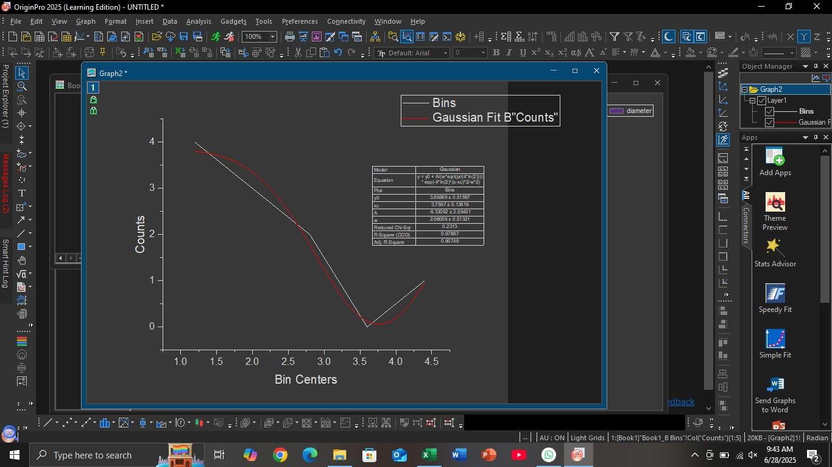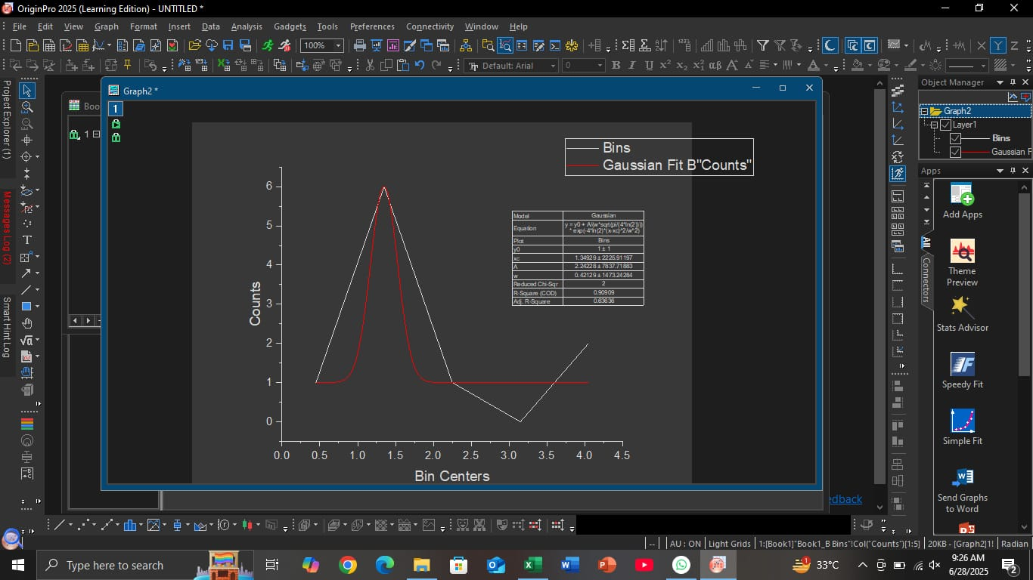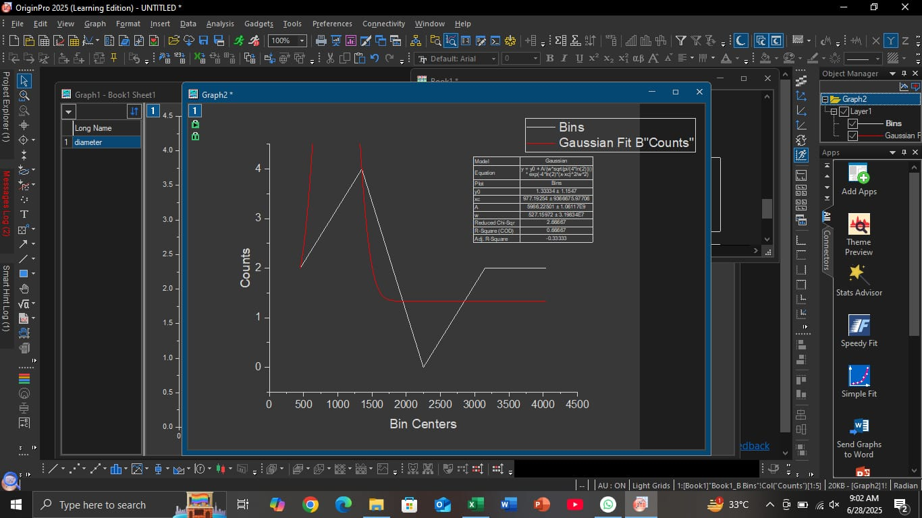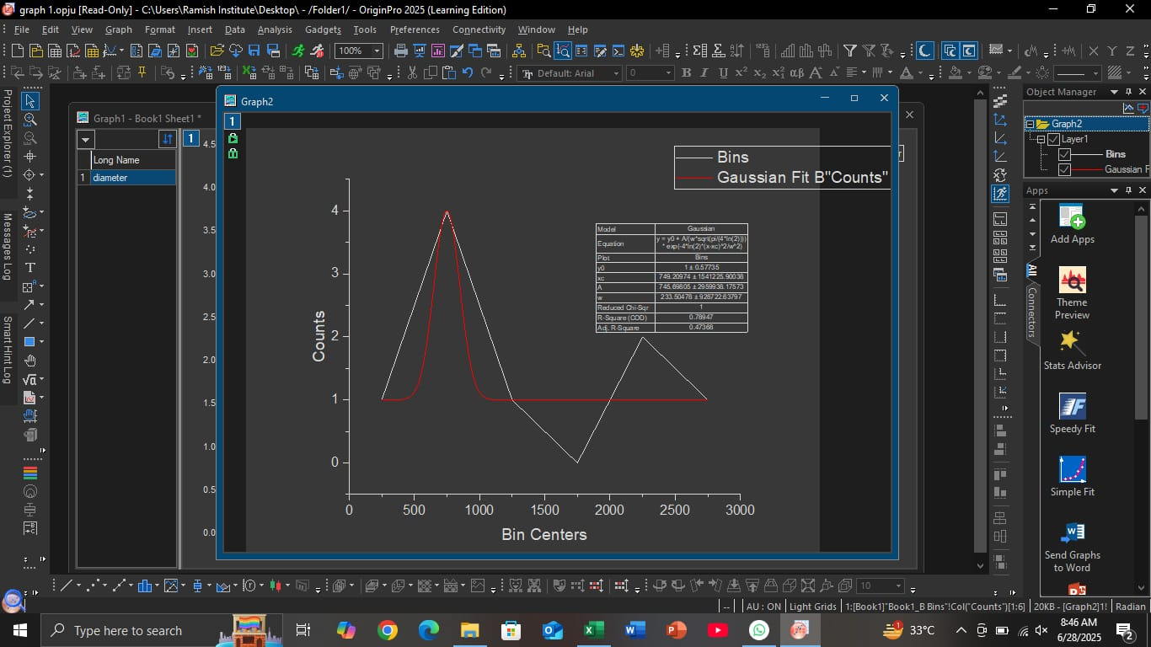**SEM Graph**

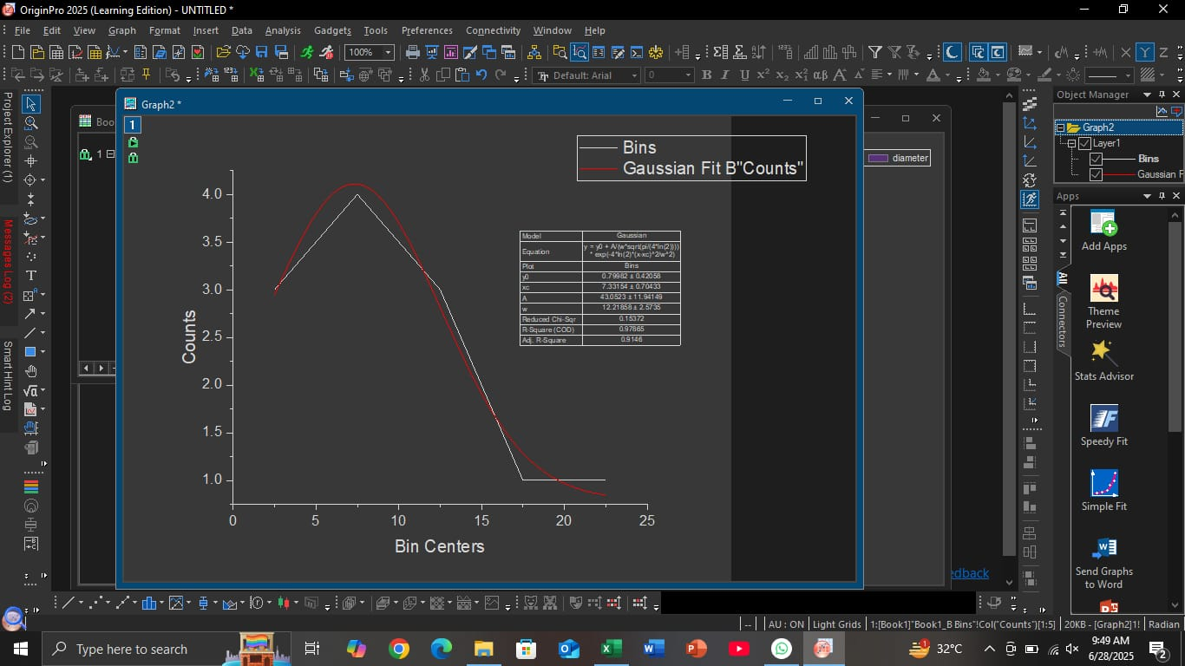

**U.V Visible Spectroscopy**

UV-Visible spectroscopy is a technique that helps us understand how a material interacts with ultraviolet (UV) light. When UV light passes through a material like pure TiO₂, some wavelengths are absorbed based on the electronic structure and concentration of the material.

**Absorption Data Table with Comparison**

|  |  |  |
| --- | --- | --- |
| **Wavelength (nm)** | **Absorbance** | **Trend** |
| 200.0 | 0.111 | Increasing |
| 201.0 | 0.122 | Increasing |
| 202.0 | 0.131 | Increasing |
| 203.0 | 0.139 | Increasing |
| 204.0 | 0.145 | Increasing |
| 205.0 | 0.150 | Increasing |
| 206.0 | 0.154 | Increasing |
| 207.0 | 0.156 | Increasing |
| 208.0 | 0.158 | Peak Absorbance Begins |
| 209.0 | 0.158 | Peak Absorbance |
| 210.0 | 0.157 | Slight Decrease |
| 211.0 | 0.154 | Decreasing |
| 212.0 | 0.150 | Decreasing |
| 213.0 | 0.145 | Decreasing |
| 214.0 | 0.138 | Decreasing |
| 215.0 | 0.131 | Decreasing |
| 216.0 | 0.124 | Decreasing |
| 217.0 | 0.116 | Decreasing |
| 218.0 | 0.108 | Decreasing |
| 219.0 | 0.100 | Decreasing |
| 220.0 | 0.092 | Decreasing |
| 221.0 | 0.084 | Decreasing |
| 222.0 | 0.077 | Decreasing |
| 223.0 | 0.071 | Decreasing |
| 224.0 | 0.065 | Decreasing |
| 225.0 | 0.061 | Decreasing |
| 226.0 | 0.056 | Decreasing |
| 227.0 | 0.053 | Decreasing |
| 228.0 | 0.050 | Decreasing |
| 229.0 | 0.048 | Decreasing |

**Analysis from the Table**

From 200 nm to 209 nm, the absorbance steadily increases, indicating that pure TiO₂ strongly interacts with UV light in this region. The peak absorbance occurs at 208–209 nm, showing the maximum light absorption capability of the material.

From 210 nm onwards, the absorbance begins to decrease, which means that pure TiO₂ becomes less responsive to longer wavelengths. This behavior is typical for semiconducting materials like TiO₂ and helps confirm its optical activity and band gap behavior.

**Graph**

This UV analysis, we plotted a graph with the following:

* **X-axis:** Wavelength (in nanometers, nm), ranging from 200 nm to 229 nm
* **Y-axis:** Absorbance, which shows how much UV light is absorbed by the sample

The graph starts with low absorbance at 200 nm (0.111). As the wavelength increases, the absorbance also rises. The curve smoothly goes upward, reaching the highest point around 208–209 nm, where the absorbance value is 0.158. After this peak, the absorbance gradually decreases to 0.048 at 229 nm.

This pattern forms a smooth, hill-like shape, which is common in UV-Vis absorption studies of many materials, including metal oxides like TiO₂.

**Graph Interpretation – Pure TiO₂**

**Rising Slope (200–209 nm):**

The curve rises steadily, indicating that pure TiO₂ absorbs more UV light as the wavelength increases.

This means that electronic transitions are occurring, and TiO₂ strongly interacts with UV radiation in this region.

**Absorption Peak (208–209 nm):**

This is the maximum absorbance region for pure TiO₂, where absorbance reaches 0.158.

The peak corresponds to the electronic transitions within TiO₂, where UV light provides enough energy to excite electrons.

**Falling Slope (210–229 nm):**

After the peak, the graph declines, showing that TiO₂ absorbs less UV light at longer wavelengths.

This means the electrons in the material are less likely to be excited by lower-energy (longer-wavelength) UV light.

**Analysis Photoluminescence (PL) Spectroscopy**

Photoluminescence (PL) spectroscopy is a non-destructive technique used to study the optical behavior of semiconducting materials. It provides valuable information about how electrons and holes recombine in the material and at which wavelengths light is emitted when the material is excited.

In this study, pure TiO₂ thin films were prepared and analyzed to understand their PL characteristics. The data was collected using a JASCO spectrometer, with a step size (ΔX) of 0.5 nm, covering a wavelength range from 250 nm to 750 nm.

**Purpose of PL for Pure TiO₂:**

* To observe the light emission behavior of TiO₂ after absorbing photons.
* To analyze how electrons return to lower energy levels and release energy in the form of light.
* To check for defects or oxygen vacancies, which also affect the PL response.
* PL Spectrum Analysis of Pure TiO₂ Thin Films

**Sample 1:**

* Initial Intensity at 250 nm: 551.29 a.u.
* Peak intensity observed between 270–273 nm (~700 a.u.)
* The PL curve shows a gentle rise before gradually decreasing.

**Interpretation:**

This broad and relatively weak emission suggests low radiative recombination activity. The stable curve indicates that the material has a low density of surface or lattice defects, which is typical for pure TiO₂. Suitable for basic UV light detection applications.

**Sample 2:**

* Initial Intensity: 1609.41 a.u. at 250 nm
* Smooth decrease to ~1189 a.u. at 286 nm, with no sharp peaks

**Interpretation:**

This smooth emission profile suggests the presence of uniformly distributed intrinsic energy states in pure TiO₂. The absence of sharp peaks indicates fewer localized defect centers, confirming good crystallinity and minimal oxygen vacancies. This makes it reliable for steady UV emission response.

**Sample 3:**

* Highest Intensity at 250 nm: 2352.28 a.u.
* Gradual decrease to ~1519.55 a.u. at 280 nm

**Interpretation:**

This sample displays strong photoluminescence, which may be attributed to a high-quality crystalline structure. The absence of abrupt changes in the curve suggests a smooth energy transition and minimal structural irregularities. The high intensity confirms efficient electron-hole recombination in pure TiO₂.

**Sample 4:**

* Initial Intensity at 250 nm: 2590.08 a.u.
* Broad emission with a consistent decrease across the UV range

**Interpretation:**

This sample shows excellent PL response, likely due to efficient energy band-to-band transitions. The broad emission indicates the presence of well-distributed intrinsic states and possibly surface-related transitions common in pure TiO₂. It is Ideal for UV-sensitive applications.

**Sample 5:**

* Intensity starts at 2590.08 a.u. at 250 nm
* Smooth decrease with minor fluctuations to ~1807.85 a.u. at 283 nm

**Interpretation:**

This spectrum shows strong and consistent PL emission. The minor fluctuations could be due to surface defects or shallow traps, which are still characteristic of pure TiO₂ thin films. The stable trend suggests the material is suitable for optical devices, particularly those requiring uniform UV response.

**Table of PL Intensities**

Photoluminescence (PL) Data Table for Pure TiO₂ Thin Films

|  |  |  |  |  |
| --- | --- | --- | --- | --- |
| **Sample No.** | **Intensity at 250 nm (a.u.)** | **Intensity at 280 nm (a.u.)** | **Emission Nature** | **Notes** |
| Sample 1 | 551.29 | ~615.49 | Weak, broad | Mild peak around 270–273 nm |
| Sample 2 | 1609.41 | ~1189.24 | Broad and smooth | Continuous decline, no sharp peak |
| Sample 3 | 2352.28 | ~1519.55 | Strong, broad | Smooth drop, high intensity |
| Sample 4 | 2590.08 | ~1807.85 | Very strong, smooth | Highest PL among all samples |
| Sample 5 | 2590.08 | ~1807.85 | Strong with slight fluctuation | Minor rises and dips |

**Graph Interpretation for Pure TiO₂ PL Spectra**

All five samples of pure TiO₂ thin films exhibited photoluminescence in the ultraviolet (UV) region, with emission intensities and trends slightly varying from sample to sample. The PL curves were mostly smooth and broad, indicating a typical emission behavior of crystalline TiO₂ without sharp structural defects.

* Sample 1 had the weakest emission, suggesting lower recombination of electron-hole pairs or fewer surface trap states.
* Samples 3, 4, and 5 showed stronger PL responses, especially Sample 4, which had the highest intensity (~2590 a.u.), pointing to a better crystalline structure and efficient optical behavior.
* Samples 4 and 5 showed minor fluctuations in the curve, which may be due to the presence of surface or intrinsic trap states—a common feature even in undoped TiO₂ films.

The smooth and broad curves across all samples reflect good thin film quality and consistent UV emission, which is essential for applications like UV detectors, photocatalysts, or optical coatings.

**4.6 Limitations of the Study**

While pure TiO₂ coatings showed some promising outcomes, there are still several limitations that must be addressed in future studies. Recognizing these limitations is crucial for improving the reliability, accuracy, and applicability of future research in this area.

**Limited Sample Size**

In our project, only a small number of surgical instruments were tested. A larger sample size would provide more reliable and statistically significant results. Future research should involve more instruments of various shapes and materials to confirm the consistency of findings.

**Short Testing Duration**

The salt spray corrosion test was conducted over a limited period. However, real-life corrosion is a slow process that may take months or even years. Future work should include long-term testing to evaluate how the coating performs during prolonged use in hospital or clinical environments.

**Lack of Real Environmental Conditions**

Our corrosion tests were performed under controlled lab conditions. In actual healthcare settings, factors like temperature fluctuations, humidity, exposure to body fluids, and sterilization chemicals can significantly affect coating performance. Future studies should simulate these real-world conditions to obtain more practical results.

**Single Coating Method Used**

We used only one method to apply the pure TiO₂ coating. Future investigations should explore multiple coating techniques such as sol-gel, chemical vapor deposition (CVD), or plasma spraying to compare their effects on adhesion, uniformity, and corrosion resistance.

**No Doping Element Investigated**

In this study, we focused only on pure TiO₂ without the inclusion of dopants. Future research should explore the addition of doping elements like Cu, Zn, Ag, or others to examine if the properties of TiO₂ coatings can be enhanced, particularly in terms of corrosion resistance and antibacterial activity.

**No Detailed Biocompatibility Testing**

Since the coatings are intended for biomedical use, biocompatibility is a critical factor. However, we did not perform detailed biological evaluations. Future research should include cytotoxicity and cell culture studies to confirm the safety of pure TiO₂ coatings for surgical applications.

**Surface Roughness and Thickness Not Controlled**

The surface texture and thickness of the coating can impact its performance, especially corrosion resistance and adhesion. These factors were not precisely measured or controlled in our study. Future research should pay closer attention to these parameters for improved performance.

**No Advanced Characterization Techniques Used**

Basic characterization methods such as XRD, SEM, and UV-Vis were used. For more in-depth analysis, advanced techniques like TEM (Transmission Electron Microscopy), XPS (X-ray Photoelectron Spectroscopy), and AFM (Atomic Force Microscopy) should be utilized to better understand the structural and chemical properties of the coating.

**Mechanical Properties Not Studied**

We did not evaluate mechanical properties such as hardness, wear resistance, or scratch resistance, which are important for tools exposed to frequent handling. Future research should include these tests to assess the durability and suitability of pure TiO₂ coatings in surgical environments.